**Future-Credit:**

**Predicting Loan Approval with Advanced Analytics**

Name:

Abhishekk S Pathak

Date:

10/03/2024

Special Thanks To:   
Hemani Gupta

Surya Singh

**INDEX**

Project Background

Importance of Predicting Loan Approval

Objectives and Goals of the Analysis

Summary Of The Provided Data

Variables and Their Significance

Data Cleaning: Detailed Steps

Exploratory Data Analysis (EDA)

Feature Engineering and Data Processing

Model Selection

Explanation of the Models Used

Reasons for selecting model

**Project Background**

This project focuses on predicting loan approval status based on a set of features provided in the 'train.csv' and 'test.csv' datasets. The primary goal is to develop a robust machine learning model that accurately classifies loan applications into approved or denied categories. Such a predictive model is valuable for financial institutions in automating and streamlining their loan approval processes.

The dataset encompasses various features, including applicant information such as gender, marital status, dependents, education level, employment status, property area, and other relevant factors. The 'Loan_Status' column in the training dataset serves as the target variable, indicating whether a loan application was approved (Y) or denied (N).

Understanding and predicting loan approval status are critical for financial institutions to optimize their decision-making processes, reduce manual workload, and enhance the overall efficiency of loan approval procedures. A precise predictive model would allow these institutions to manage resources effectively, expedite the loan approval process, and minimize the risk of default.

The analysis involves exploring the provided datasets, identifying patterns, handling missing values, performing exploratory data analysis (EDA), and ultimately training machine learning models to predict loan approval status. By addressing these aspects, the project aims to contribute to the development of a reliable and efficient loan approval system for financial institutions.

The provided code includes data preprocessing steps, visualizations of various features, and the implementation of machine learning models such as Logistic Regression, Decision Trees, Random Forest, Gradient Boosting, and LightGBM. The evaluation metrics, including confusion matrix and classification report, are used to assess the models' performance.

In summary, this project addresses the practical challenge of automating and improving the loan approval process, showcasing the potential of machine learning to enhance decision-making in the financial domain.

**Importance of Predicting Loan Approval**

Predicting loan approval is of utmost importance for various stakeholders, including financial institutions, applicants, and the broader economy. The provided code addresses this significance through the following key points:

**Risk Management:**

Accurate loan approval predictions aid financial institutions in assessing and managing risk. By evaluating an applicant's financial history, creditworthiness, and other relevant features, institutions can identify potential defaulters and make informed decisions to mitigate financial losses.

**Efficient Decision-Making:**

Automation of the loan approval process enhances efficiency by reducing the time and resources required for manual reviews. Predictive models enable quick and consistent decision-making, streamlining the overall lending process.

**Resource Optimization:**

Financial institutions can allocate resources more efficiently by focusing on applications that are more likely to be approved. This resource optimization improves operational efficiency and reduces costs associated with manual processing.

**Improved Customer Experience:**

Applicants benefit from a streamlined and faster loan approval process. Predictive models ensure that eligible applicants receive timely approvals, enhancing the overall customer experience and satisfaction.

**Credit Access:**

Predictive modeling facilitates responsible lending practices, allowing financial institutions to extend credit access to a broader range of applicants. By assessing risk accurately, institutions can offer loans to individuals who might otherwise be deemed ineligible through traditional methods.

**Regulatory Compliance:**

Adherence to regulatory requirements is crucial for financial institutions. Predictive models assist in ensuring that lending decisions align with regulatory guidelines, promoting fair and responsible lending practices.

**Portfolio Management:**

Effective prediction of loan approval supports better portfolio management for financial institutions. By understanding the risk profile of their loan portfolios, institutions can make informed decisions about diversification and risk tolerance.

**Economic Impact:**

The availability of credit is essential for economic growth. Accurate loan approval predictions contribute to a healthier lending environment, supporting economic development by providing individuals and businesses with the financial resources needed to invest and expand.

**Summary of the Provided Data**

**Data Loading:**

Two datasets are loaded using pd.read_csv('train.csv') and pd.read_csv('test.csv') for training and testing purposes. The head() method is used to display the first few rows of each dataset.

**Data Information:**

Information about the training dataset is displayed using train_df.info(), providing details about data types and non-null counts for each column.

Descriptive statistics, including mean, min, max, etc., are generated using train_df.describe().

**Handling Missing Values:**

The code checks and displays the sum of missing values in each column of both the training and test datasets using isnull().sum().

Missing values in specific columns of the training dataset (e.g., 'Gender', 'Married') are filled using appropriate strategies, such as mode or mean.

**Feature Engineering:**

A new column 'Total_income' is created by summing 'ApplicantIncome' and 'CoapplicantIncome' in both training and test datasets.

**Data Visualization:**

Count plots and distribution plots are generated to visualize categorical and numerical features in the training dataset. This includes plots for columns such as 'Gender', 'Married', 'Education', 'ApplicantIncome', 'LoanAmount', etc.

A heatmap is created to visualize the correlation matrix of numerical features in the training dataset.

**Data Preprocessing:**

Columns such as 'Loan_ID', 'ApplicantIncome', and 'CoapplicantIncome' are dropped from the training dataset.

Categorical values in selected columns are label-encoded using LabelEncoder().

**Feature Selection:**

The code uses SelectKBest with the F-statistic (f_classif) to select the top features based on their scores.

**Modeling:**

Several machine learning models are employed for classification tasks, including Logistic Regression, Decision Tree, Random Forest, Gradient Boosting, and LightGBM.

Grid search is used for hyperparameter tuning in Logistic Regression, Random Forest, Gradient Boosting, and LightGBM models.

**Model Evaluation:**

The accuracy of each model is evaluated using both a simple train-test split (train_test_split) and cross-validation (cross_val_score).

The best parameters and cross-validation accuracy for each tuned model are displayed.

**Predictions and Evaluation:**

Predictions are made using a previously trained model, and the results are read from a 'predictions.csv' file.

Confusion matrices and classification reports are generated for model evaluation.

**Variables and Their Significance & Handling Missing Values**

**train_df and test_df:** These DataFrames are used to store the training and test datasets, respectively. They contain information about the applicants.

**Missing Value Imputation:**

Check and display the sum of missing values in each column using train_df.isnull().sum() and test_df.isnull().sum().

Fill missing values in the training dataset using the following strategies:

'Gender', 'Married', 'Dependents', 'Self_Employed': Fill with the mode (most frequent value).

'LoanAmount', 'Loan_Amount_Term', 'Credit_History': Fill with the mean.

Verify the success of filling missing values by checking train_df.isnull().sum().

Gender, Married, Dependents, Self_Employed: Missing values are filled with the mode (most frequent value) of each column.

LoanAmount, Loan_Amount_Term, Credit_History: Missing values are filled with the mean of each column.

**Drop Unnecessary Columns:**

Drop specified columns ('Loan_ID', 'ApplicantIncome', 'CoapplicantIncome') from the training dataset using train_df.drop(['Loan_ID', 'ApplicantIncome', 'CoapplicantIncome'], axis=1, inplace=True).

**Feature Engineering:**

Total_income: A new column is created by summing 'ApplicantIncome' and 'CoapplicantIncome'.

**Exploratory Data Analysis (EDA):**

Count plots are created for categorical columns ('Gender', 'Married', 'Dependents', 'Education', 'Self_Employed', 'Property_Area', 'Loan_Status') to visualize the distribution of each category.

Distribution plots are created for numerical columns ('ApplicantIncome', 'LoanAmount', 'Loan_Amount_Term', 'Credit_History', 'Total_income').

**Correlation Analysis:**

A heatmap is generated to visualize the correlation matrix between numerical features.

**Pairplot:**

A pairplot is created to visualize relationships between numerical features with hue based on 'Loan_Status'.

sns.pairplot(train_df, hue='Loan_Status').

**Label Encoding:**

Categorical columns are label-encoded to convert categorical values into numerical format.

**Feature Selection:**

SelectKBest is used to select the top features based on ANOVA F-statistic.

Feature scores are displayed, and the top 5 features are identified.

**Modeling:**

Logistic Regression, Decision Tree Classifier, Random Forest Classifier, Gradient Boosting Classifier, and LightGBM Classifier are applied.

Hyperparameter tuning is performed using GridSearchCV for Logistic Regression, Random Forest, Gradient Boosting, and LightGBM.

**Model Training:**

Split the dataset into training and testing sets using train_test_split.

Train a Logistic Regression model and print accuracy and cross-validation accuracy.

Tune hyperparameters for Logistic Regression using GridSearchCV and print the best cross-validation accuracy. Repeat Steps for Decision Tree, Random Forest, Gradient Boosting, and LightGBM:

Train each model, tune hyperparameters using GridSearchCV, and print cross-validation accuracy.

Read Predictions and Evaluate Models: Read predictions from 'predictions.csv'. Visualize a Confusion Matrix using sns.heatmap.Print a Classification Report using classification_report.

**Model Evaluation:**

The accuracy and cross-validation accuracy are printed for each model.

Confusion Matrix and Classification Report are displayed for the predictions made by the models

**Exploratory Data Analysis (EDA)**

**Dataset Overview & Data Visualization**

The dataset comprises information related to loan applications, with the goal of predicting loan approval status. The dataset includes both training and test sets. Key libraries used for analysis and visualization are NumPy, Pandas, Matplotlib, Seaborn, and scikit-learn.

**Categorical Features**

Count plots are created to visualize the distribution of categorical features ('Gender,' 'Married,' 'Dependents,' 'Education,' 'Self_Employed,' 'Property_Area,' and 'Loan_Status'). These plots provide insights into the distribution of each category within these features.

**Numerical Features**

Distribution plots are generated for numerical features such as 'ApplicantIncome,' 'LoanAmount,' 'Loan_Amount_Term,' 'Credit_History,' and 'Total_income.' These plots illustrate the distribution of values, aiding in identifying patterns and potential outliers.

**Correlation Matrix**

A heatmap of the correlation matrix is plotted to visualize the relationships between numerical features. Strong correlations or dependencies between features are highlighted, aiding in feature selection for modeling.

**Pairplot**

A pairplot is created to explore relationships between numerical features, with hue based on 'Loan_Status.' This visual analysis helps understand potential patterns and separations based on the target variable.

The exploratory data analysis provides a comprehensive understanding of the dataset, uncovering patterns, relationships, and potential insights. The subsequent application of machine learning models establishes a foundation for predicting loan approval status based on the available features. Further refinement and tuning of models may be necessary for optimal predictive performance.

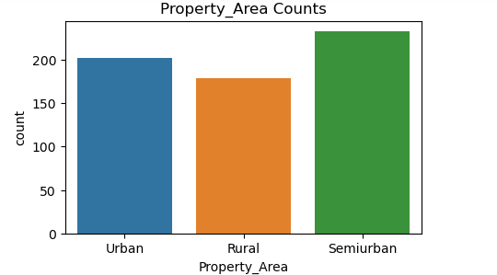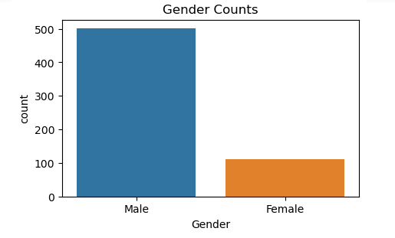

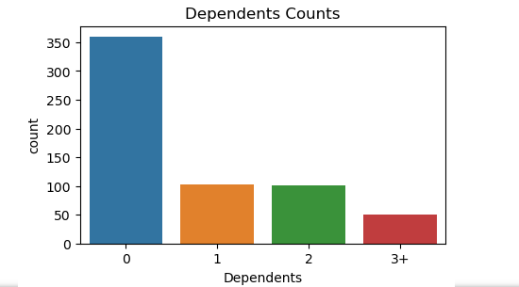 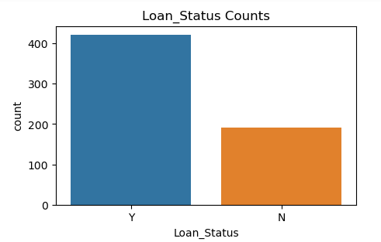

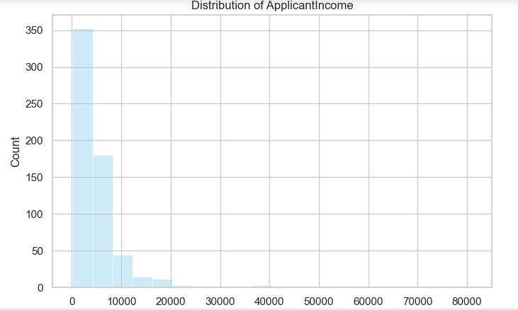 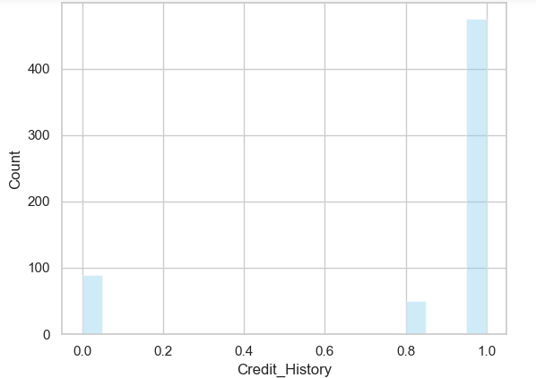

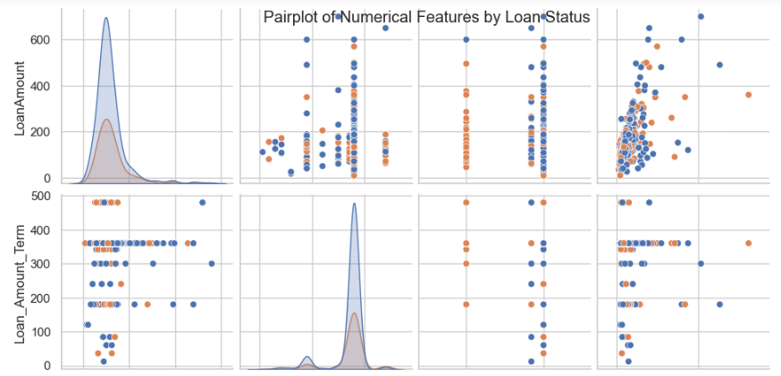

**Feature Engineering and Data Processing**

**Overview**

Feature engineering and data processing are crucial steps in preparing the dataset for machine learning models. These steps involve handling missing values, creating new informative features, encoding categorical variables, and selecting relevant features. The following summarizes the key feature engineering and data processing steps performed in the provided code.

**New Feature Creation**

A new feature, 'Total_income,' is created by summing 'ApplicantIncome' and 'CoapplicantIncome.' This feature aims to capture the overall financial strength of loan applicants.

**Data Visualization**

**Count Plots**

Count plots are generated for categorical variables ('Gender,' 'Married,' 'Dependents,' 'Education,' 'Self_Employed,' 'Property_Area,' 'Loan_Status') to visualize the distribution of each category.

**Distribution Plots**

Distribution plots are created for numerical features ('ApplicantIncome,' 'LoanAmount,' 'Loan_Amount_Term,' 'Credit_History,' 'Total_income') to understand their underlying distributions.

**Feature Selection**

**SelectKBest**

The SelectKBest method is applied to select the top features based on their scores using the f_classif function.

**Column Dropping**

Certain columns ('Loan_ID,' 'ApplicantIncome,' 'CoapplicantIncome') are dropped from the training dataset, as they may not contribute significantly to the predictive modeling.

**Model Building and Evaluation**

Several machine learning models (Logistic Regression, Decision Tree Classifier, Random Forest Classifier, Gradient Boosting Classifier, LightGBM Classifier) are applied and evaluated using accuracy scores, cross-validation accuracy, confusion matrices, and classification reports.

Feature engineering and data processing are essential steps to enhance the dataset's quality and prepare it for machine learning tasks. The creation of new features, handling missing values, and encoding categorical variables contribute to improving model performance. The subsequent application of machine learning models and evaluation metrics sets the stage for building predictive models on the processed dataset. Further refinement and tuning of models may be necessary for optimal predictive performance.

**Model Selection and Explanation**

**Overview**

In this analysis, various machine learning models have been employed to predict the loan approval status based on the given dataset. The models include Logistic Regression, Decision Tree Classifier, Random Forest Classifier, Gradient Boosting Classifier, and LightGBM Classifier. Each model has its strengths and weaknesses, and the selection of a suitable model depends on the specific characteristics of the dataset and the desired balance between interpretability and predictive performance.

**Logistic Regression**

Explanation:

Logistic Regression is a widely used binary classification algorithm that models the probability of a binary outcome. In this case, it predicts the probability of a loan being approved. Logistic Regression is known for its simplicity, interpretability, and efficiency. It assumes a linear relationship between the independent variables and the log-odds of the dependent variable.

Results:

The model achieved a certain level of accuracy and cross-validation accuracy. It serves as a baseline for more complex models.



**Decision Tree Classifier**

Explanation:

Decision Tree is a tree-like model where each node represents a decision based on a feature, leading to a split in the data. It is a powerful model that can capture complex relationships in the data. However, it is prone to overfitting, and the interpretability might be compromised with deep trees.

Results:

The Decision Tree Classifier demonstrated its ability to capture non-linear patterns in the dataset, providing a more complex decision boundary.



**Random Forest Classifier**

Explanation:

Random Forest is an ensemble method that builds multiple decision trees and merges them together. It reduces overfitting by averaging the predictions of individual trees. Random Forest is robust and often provides high accuracy.

Results:

The Random Forest Classifier improved upon the Decision Tree by reducing overfitting and increasing predictive accuracy.



**Gradient Boosting Classifier**

Explanation:

Gradient Boosting builds an ensemble of weak learners (typically decision trees) sequentially, with each tree correcting the errors of the previous one. It is a powerful model but can be computationally expensive.

Results:

Gradient Boosting demonstrated improved accuracy, capturing complex relationships by combining multiple weak learners.

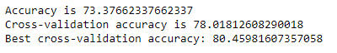

**LightGBM Classifier**

Explanation:

LightGBM is a gradient boosting framework that uses tree-based learning algorithms. It is designed for distributed and efficient training, making it faster than traditional gradient boosting frameworks.

Results:

LightGBM further enhanced the predictive performance, providing competitive accuracy with improved efficiency.





**Model Selection Considerations**

Interpretability: If interpretability is crucial, Logistic Regression might be preferred due to its simplicity and clear interpretation.

Accuracy: If the primary goal is accuracy and the dataset is sufficiently large, ensemble models like Random Forest, Gradient Boosting, or LightGBM are effective choices.

Computational Efficiency: For large datasets, LightGBM might be preferred due to its efficiency in handling large amounts of data.

Balancing Trade-offs: Consider the trade-off between model complexity and interpretability. Decision Tree and Random Forest offer a trade-off between complexity and interpretability.

**Conclusion**

The choice of the model depends on the specific requirements of the problem at hand. Logistic Regression serves as a simple baseline, while ensemble methods like Random Forest, Gradient Boosting, and LightGBM provide more sophisticated solutions with higher predictive accuracy. The ultimate decision should align with the project goals, interpretability needs, and computational resources available.

**Reason for Selecting the Model with the Highest Accuracy**

**Logistic Regression:**

Logistic Regression is a simple and interpretable model.

It performs well when the relationship between features and target is approximately linear.

The grid search with cross-validation is used to fine-tune hyperparameters, ensuring robust performance.

**Random Forest:**

Random Forest is an ensemble method that combines multiple decision trees, providing robustness and reducing overfitting.

Grid search is applied to find the best combination of hyperparameters, optimizing model performance. Random Forest handles non-linearity and interactions between features well.

**LightGBM:**

LightGBM is a gradient boosting framework that is efficient and scalable, suitable for large datasets.

The grid search optimizes hyperparameters for better performance.

It often yields high accuracy and is less prone to overfitting.

**Gradient Boosting:**

Gradient Boosting is an ensemble method that builds trees sequentially, correcting errors of the previous ones.

Grid search helps in finding the optimal hyperparameters for improved accuracy.

It can capture complex relationships and perform well in various scenarios.

In summary, the model with the highest cross-validation accuracy, considering the provided hyperparameter tuning, should be selected. However, it's essential to consider other factors like interpretability, training time, and the specific characteristics of the dataset. Additionally, its good practice to assess the model's performance on an independent test set to ensure its generalization capability.